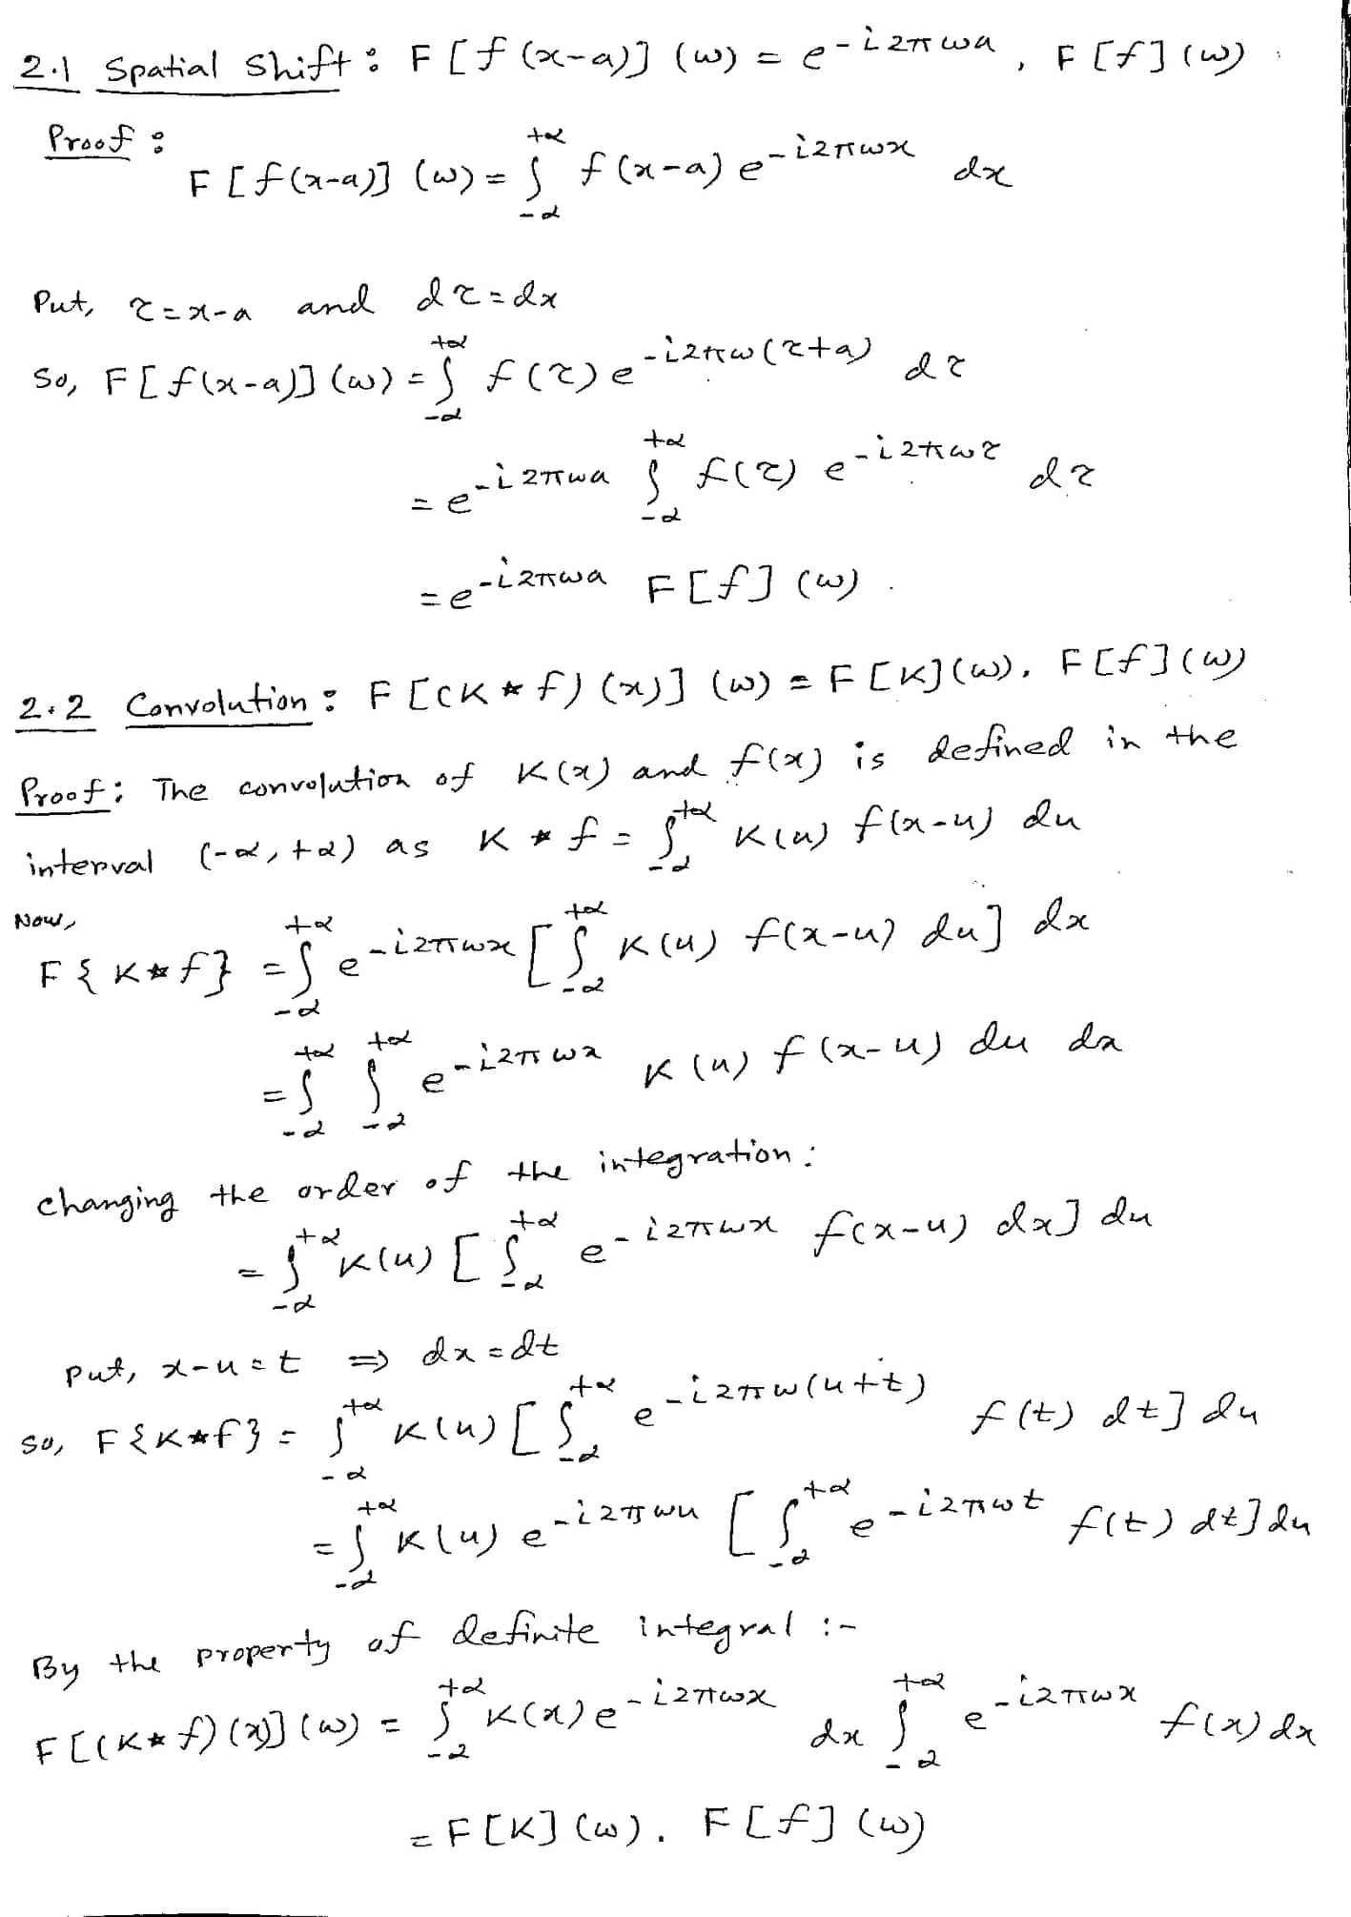

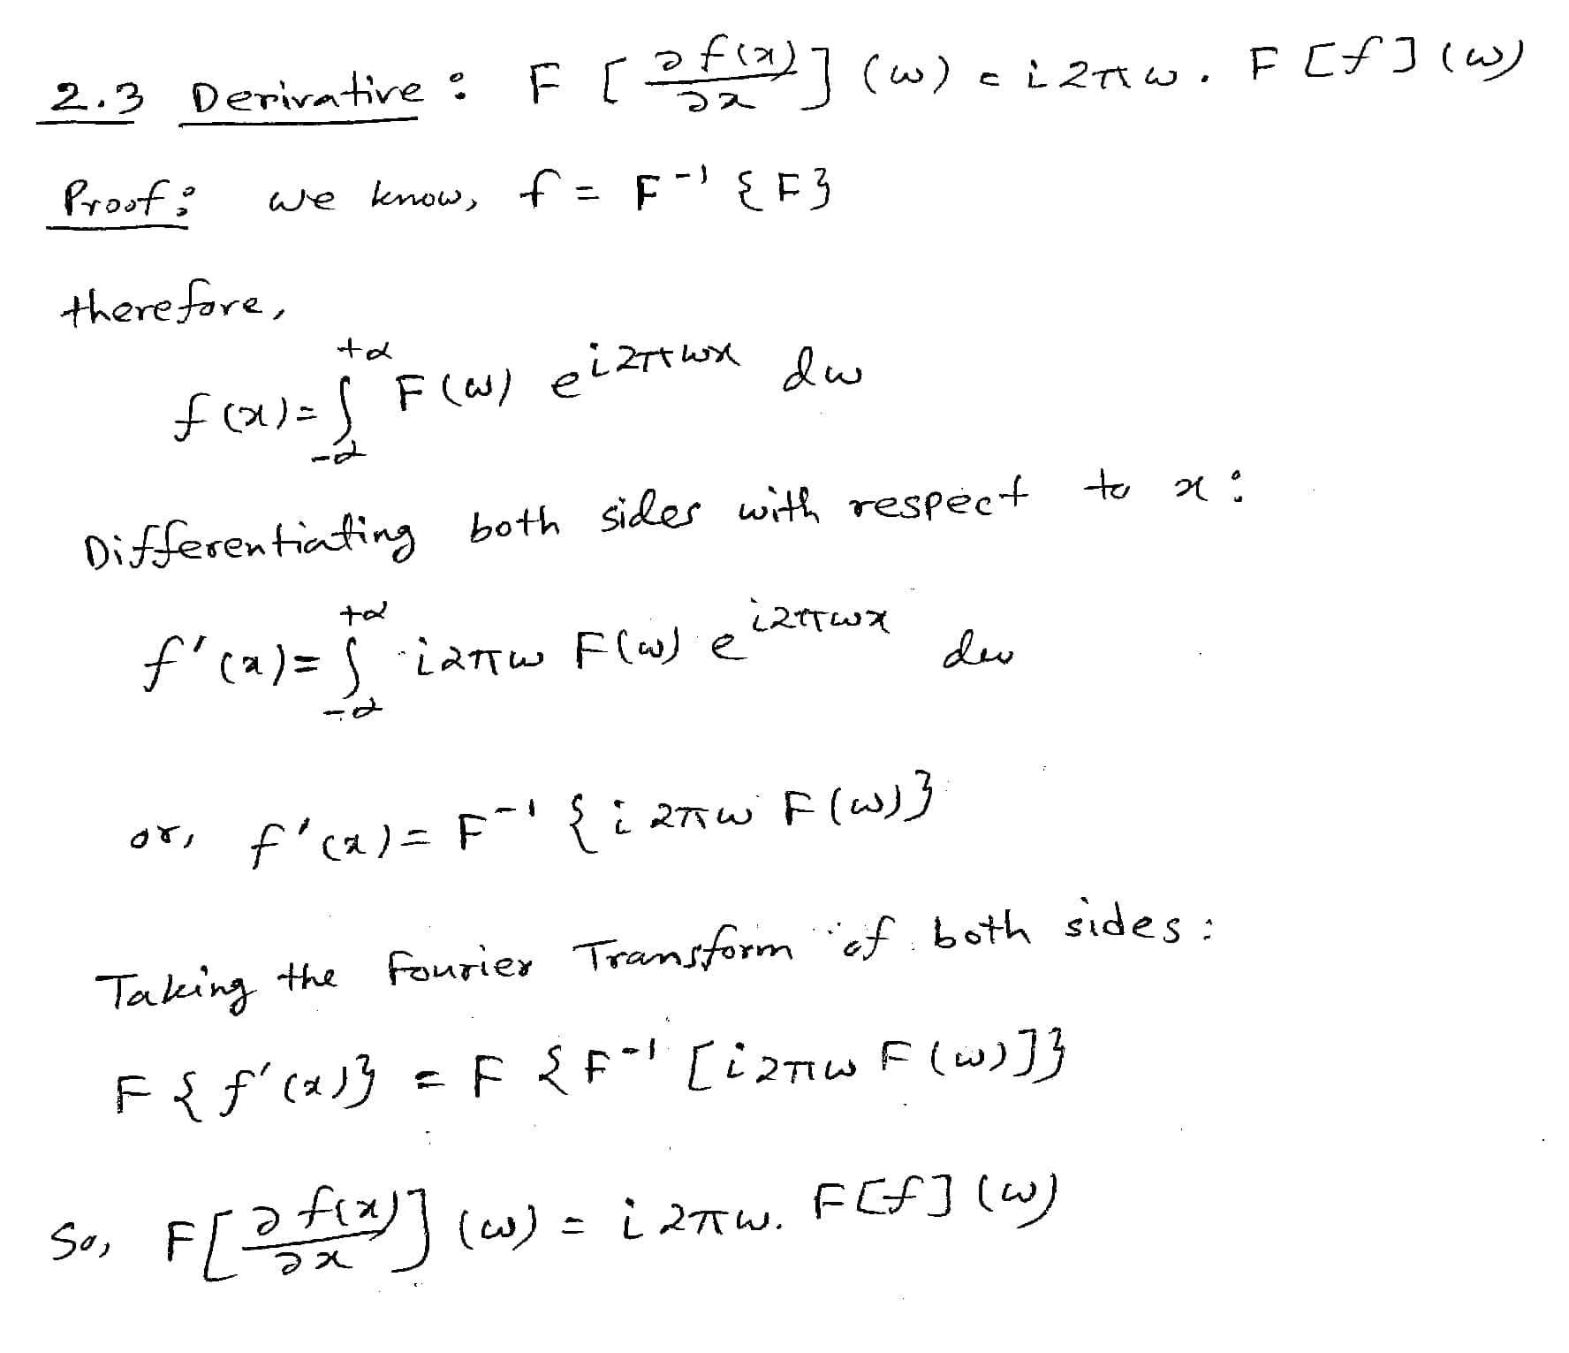

**Answer 3.1**

It’s a high pass filter. We can use this kind of filter for edge detection. The second order derivative in 1-D is:

$$f^{'}\left[n\right]= \frac{f\left[n+1\right]-2 f\left[n\right]+f[n-1]}{τ^{2}}$$